
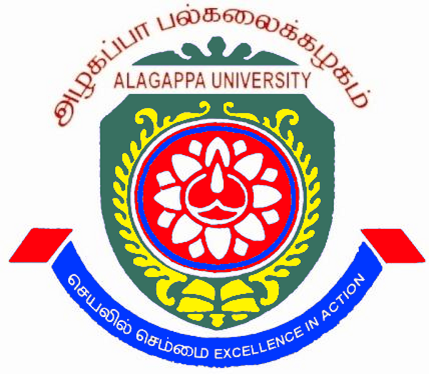
ALAGAPPA UNIVERSITY
KARAIKUDI – 6300 003

RED RIBBON CLUB

AIM |  | - To prevention HIV transmission and to control its spread in India.  - To reduce morbidity and mortality associated with HIV infection.  - To reduce the adverse social and Economic impact resulting from HIV infection.  - To coordinate and strengthen STD/HIV/AIDS surveillance.  - To provide technical support in HIV/AIDS prevention and control to Government and Non-governmental Organization.  - To enhance the community awareness about HIV/AIDS for its prevention and control.  - To develop materials for distribution and adoption by agencies working in AIDS prevention and control.  - To promote, canalize and integrate the activities of Non-government Organizations for AIDS prevention and control.  - To promote safety of blood and blood products and undertake, support and catalyze voluntary blood donation movement.  - To provide facilities and to strengthen Sexually Transmitted Diseases control services in Government and Non-government sector and Private Medical Sector.  - To develop counseling services on the disease of HIV/AIDS and related issues.  - To mobilize support social, financial or otherwise for management of HIV infected person and AIDS patients.
OBJECTIVES |  | - To understand the objectives and dynamics of RRC in higher educational institutions.  - The design appropriate and relevant activities for the RRCs.  - To understand the potential strength, barriers and constraints in the conduct of RRC activities and suggest suitable strategies to overcome.  - To redefine the roles and responsibilities of each RRC functionary.  - To develop a schedule for structured training Programs for select categories of RRC functionaries and groups.  - To discuss dissemination and advocacy activities at the macro-levels to give visibility to RRC and help formulation of policies.
ACTIVITIES |  | The RRCs of Alagappa University is organizing AIDS Awareness programs periodically. Blood Donation Camps are organized by affiliated colleges as a part of RRC activities. The awareness programme on “Sexuality and Productive Health”, “Sexuality and Transmitted Infections” and “Routes of Transmission of HIV Infection” are getting attention among the students.

Red Ribbon Club (RRC) Advisory Committee

S.No | Name and Address | Designation
1. | Prof. S. Subbiah  Vice Chancellor  Alagappa University  Karaikudi – 630003 | Chief Patron
2. | Prof. H. Gurumallesh Prabu  Registrar  Alagappa University  Karaikudi – 630003 | Patron
3. | Dr. P. Srinivasan  RRC Co-ordinator  Alagappa University  Karaikudi – 630003 | Convener
4. | Mr. G. Ajith  M. Sc., II Year  Department of Animal Health & Management  Alagappa University  Karaikudi - 630003 | Co-Convener
5. | Ms. R. Gayathri  M. Sc., II Year  Department of Physics  Alagappa University  Karaikudi - 630003 | Co-Convener
6. | Ms. P. Sangeetha  M. Sc., II Year  Department of Animal Health & Management  Alagappa University  Karaikudi - 630003 | Member
7. | Mr. S. Hari Baskar  M. Sc., II Year  Department of Mathematics  Alagappa University  Karaikudi – 630003 | Member
RED RIBBON CLUB ACTIVITY
VOLUNTEER’S BLOOD DONOR REGISTRY CAMP
Volunteer’s Blood Donor Registry Camp was organized by the Red Ribbon club Alagappa University & District AIDS Prevention & Control Unit, Sivagangai on 11.01.2017 at Conference hall, Science Campus. This Programme welcomed by Dr.Yasothamani Assistant Director, District AIDS Prevention & Control Unit, Sivagangai. Blood Donor Registry Camp was inaugurated by Thiru S. Natarajan I.A.S., Project Director, Tamil Nadu AIDS Control Unit, Chennai. Prof. S. Subbiah Vice chancellor, Alagappa University has delivered special Address in the great occasion. Dr. V. Balachandran Registrar i/c, Alagappa University, Dr.P.Soundar Rajan, Principal, Medical college, sivagangai, Dr. R. Sureshkumar, Deputy Director, Medical College, sivagangai given the felicitation. Dr.S.Rajaram has delivered vote of thanks at the end of the Programme. One thousand hundred and thirty seven volunteers has participated and registered their name in the Blood Donation Registry Camp.
